Project Idea: Smart Waste Bin Monitoring System
It is a project proposed with the aim of integrating Use of IoT Sensors, Mobile App, and Use of Cloud Database for the purpose of checking the level of Garbage bins. The overall goal of the project is ensuring that efficiency in waste management is improved for the sake of promoting environmental responsibility in our communities as well as schools.
3 Specific, Measurable Requirements
1. Real-Time Fill Level Monitoring Requirement- The Smart Waste Bin Monitoring System shall measure the bin’s fill level with 95% accuracy and update the dashboard every 5 minutes during normal operation.
2. Automated Alert Notification Requirement- The system shall send an alert notification to waste management personnel within 30 seconds when the bin reaches 80% capacity, starting immediately after system activation.
3. Waste Collection Performance Reporting Requirement- The system shall generate a weekly report summarizing bin usage, fill frequency, and collection history with 100% recorded data completeness, beginning one week after installation.
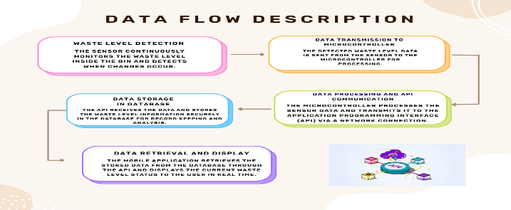
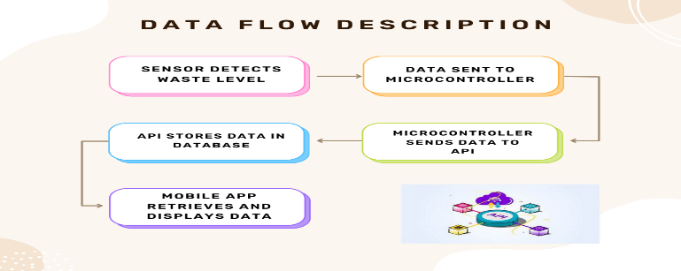
System Architecture Diagram

List 3-5 core tools per component
•IoT Sensors track •Mobile Application •Cloud Database •Processing & Control Component •Communication Component
Brief explanation of chosen why each tool is.
•IoT Sensors track how full the garbage bins are in real time. They help reduce manual checking, prevent overflow, and improve waste collection efficiency.
•Mobile Application allows users and waste management staff to easily view bin status, receive alerts, and organize collection schedules using their smartphones.
•Cloud Database securely stores all data from the sensors and makes it available anytime and anywhere, ensuring the system remains reliable and scalable.
•Processing & Control Component this component processes the data collected from sensors and controls system operations
•Communication Component is responsible for transmitting data from the smart waste bin to the server or cloud system.
Lifecycle Timeline
•Week 1: Planning & Analysis (define project objectives and system requirements) and Design (prepare the system architecture diagram).
• Week 2: Development (assemble hardware components and develop the mobile application).
• Week 3: Testing (conduct sensor accuracy tests, fix errors, and verify data transmission).
• Week 4: Deployment (integrate all system components and launch the system) and Maintenance (monitor performance and make improvements).
Grouping Process
Every group member were formed based on shared interest and responsibilities to ensure equal contribution to this project.

